
23 Pennsylvania St. Metro South Subdivision, General Trias, Cavite

Contact No. 0917-501-9955 | Email: lambatlambat@gmail.com | Website: lambat.com

December 29, 2014

Dear Ministry Partners,
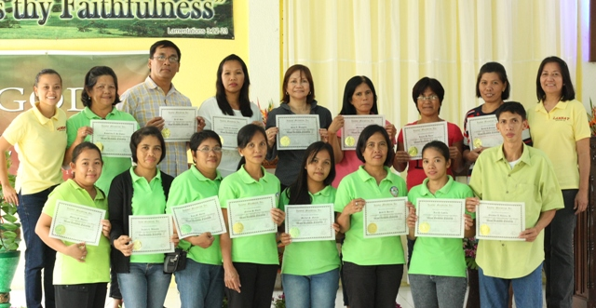
God’s grace saw us through another year. We are striking while the iron is hot. We thank God, no one is preventing us from teaching the values of Jesus Christ in public schools; no one is stopping us from sharing the good news of salvation through our values education materials to children, teens, and adults in the communities. No one is telling us not to mention God’s name in public.
Mission Mindoro Province
16 volunteer teachers received their Values Formation Facilitator certificate after finishing the four modules on values formation.

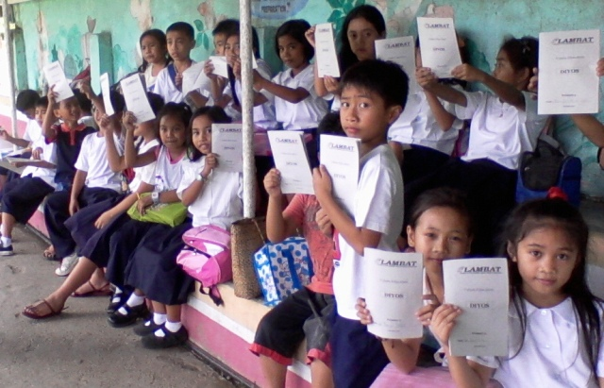

These teachers are ministering to 2,611 children in 4 public elementary schools and in one village daycare center.

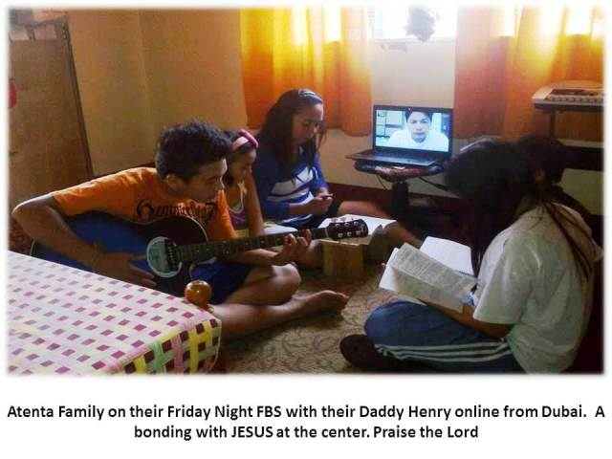

Mission Bataan Province
- We had the opportunity to conduct an overview of our values formation modules to 200 village officials wherein the Town Mayor is pushing for good governance in all its offices.
- 85 families in one congregation held weekly Sunday devotion before dinner using our material, Biblical Christian Worldview. Dad may be working in far away Dubai but he joins his family in the weekly devotion through skype - thanks to our present technology.
Mission San Fernando City, Pampanga Province
- Pastors and church leaders teach the values of Jesus Christ to parents of daycare children in 55 villages of this city.
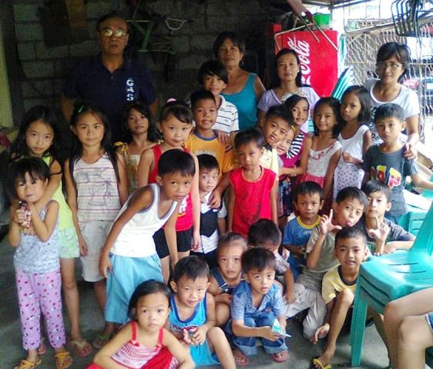
- Volunteer teachers minister to 1,409 children and teens in values clubs.
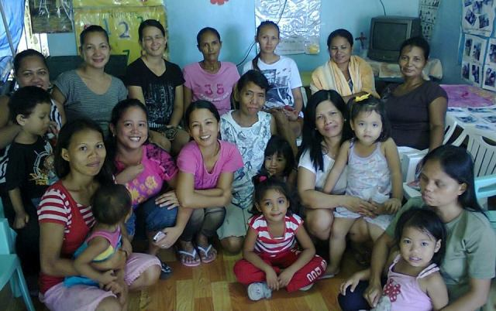
- We introduced a new module that pastors and volunteer workers can use for middle school students to create an awareness among the teens about the pressing poblem of teenage pregnancies in the country - its dangers and bad effects and how they can victoriously lead pure lives before the Lord. Several pastors have asked for this module so they can start to use it in their teens’ ministry in church and public high school.
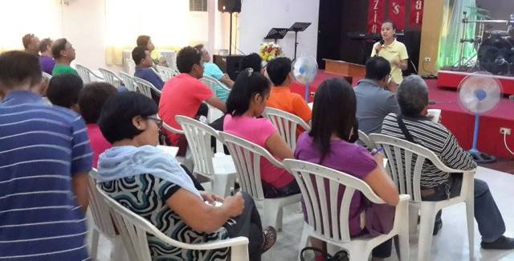

Mission Bacoor City, Cavite Province
- Husband and wife, Pastor Jun and Joji Javier, have been using our children’s materials since 2009.
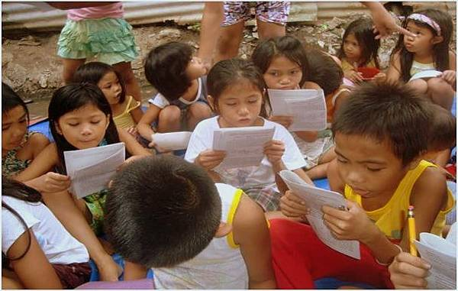
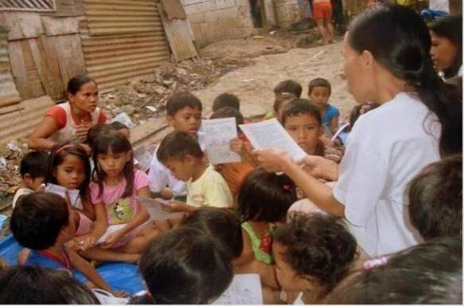

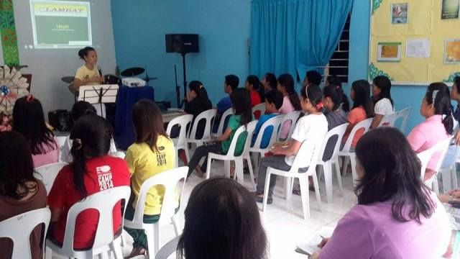
- His youth teachers underwent teaching and training with Jeena and Ann for the expansion of their ministry to children.
- He has nine community leaders and several youth volunteer teachers who are teaching 300 children in nine communities of this city and 68 children in his outreach in the Bicol Region.
- Three Headstart teachers are from his group.

Mission Majayjay, Laguna Province
- We conducted values formation overview seminars at Pastor Victor Gojo-Cruz’s church in this province. We are now helping them by providing materials for their ministry to 1, 400 children and teens in a public elementary and high school.
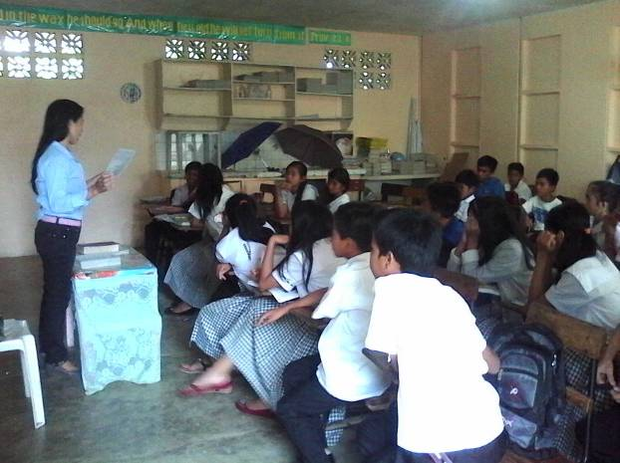
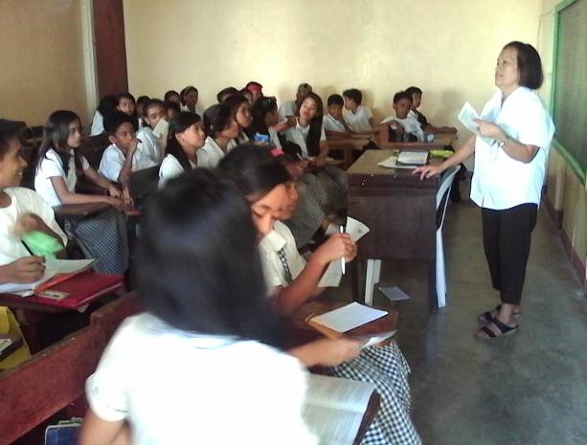

Mission Javalera, Cavite Province
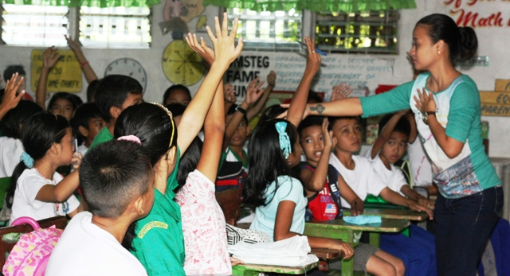
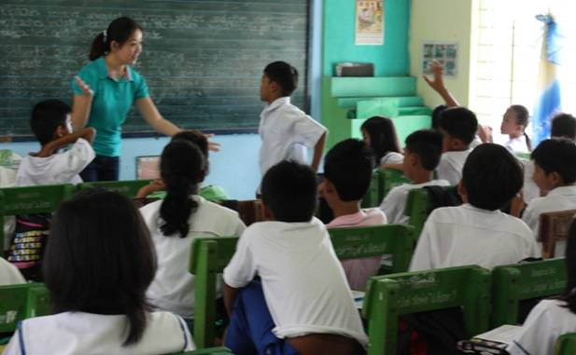
- Barangay Javalera Captain Lucita Agdon and Javalera Elementary Principal, Rea Famorcan are absolutely aware of the country’s growing problem on teen-age pregnancies. Captain Lucing suggested that we pilot test our program to their grades 5 and 6 students. Principal Rea on the otherhand openly accepted our proposal.
- After conducting the overview, Jeena and Ann meet grades 5 and 6 students once a week for their follow-up sessions.

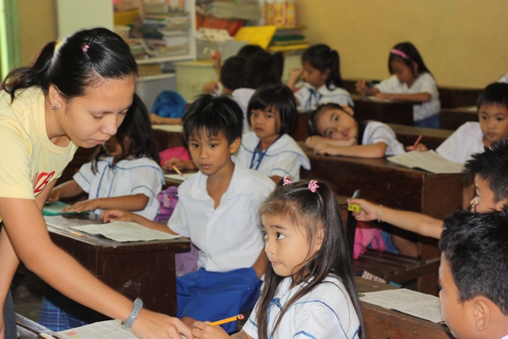
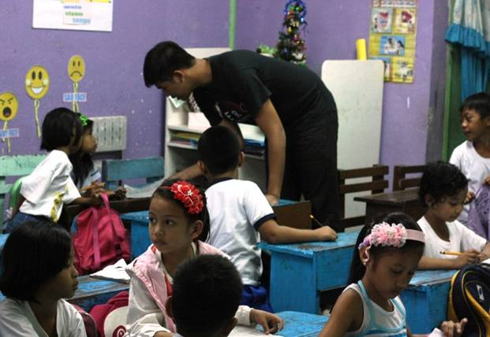
- Resa and EJ have joined our teaching staff at Javalera.
- Now, we are also teaching the values of Jesus Christ to grades 1 to 4 students once a week.
- This school has 498 students.
- The parents of these students are now being asked to attend our Godly Parenting Seminar.

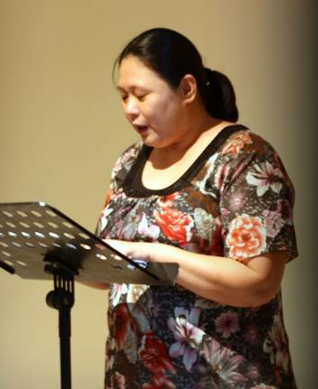
Mission Jalajala, Rizal Province
- Connie De Luna - assigned as Sunday school superintendent by her immediate Pastor, Ronald Balmaceda - has taught and trained several women leaders in their local church using our modules for values formation and church growth. She holds four weekly home Bible studies.
- She is now a member of the pastors ministerial council of this town.
- She is also teaching parents who are recipients of a government-assisted program for poor families.
- Her pastor is using our modules on hermeneutics, homilectics and apologetics for teaching all pastors and church leaders under him.

Headstart Program
- 55 kids are enrolled in our program in 5 different sites.
- Parents of students last year keep coming back to our teachers to thank them for teaching their children, giving them a headstart from other students in their class.
- Parents attest too, that the behavior of their children changed for the better since they have been taught the values of Jesus Christ every week.
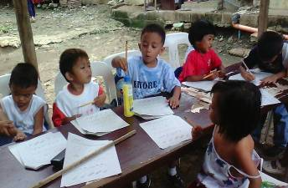
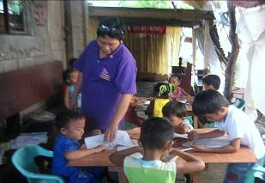

This year, we conducted 19 seminars and distributed 21,958 children and adult materials. We currently have 73 participating pastors.

Thank you for your support and prayers. We look forward to our journey with the Lord and you as partners in 2015 as we continue to expand God’s kingdom in the Philippines.

Blessings to all!

Gin J. Tolosa

